**Table of Contents:**

**Scope**…………………………………………………………………………....4

System Objectives………………………………………………………..4

Software Requirements…………………………………………………..4

Design Constrains and Limitations……………………………………....4

**Data Design**…………………………………………………………………….6

Database………………………………………………………………….6

Tables…………………………………………………………………….6

**Architecture Design**……………………………………………………………8

Use Case Diagram…………………………………………………..........8

Class Diagram……………………………................................................9

Activity Diagram………………………………………………………..11

Sequence Diagram………………………………………………………12

Deployment Diagram……………………………………........................13

**Interface Design**…………………………………………………………….....14

User and System Interface………………………………………………14

External Interface Design……………………………………………….25

Hardware Interface Design………………………...................................25

**Procedural Design**…………………………………………………………….26

Customer Registration…..………………………………..............26

Customer Login…………………………………………………..26

View Transactions….………………………………….................27

Fund Transfer…………………………………………………….27

Lodge Complaints………………………………………………..27

Check Complaint Status…….………………………………........28

Change Credentials………………………………………………28

Logout……………………………………………………………28

**SCOPE:**

**System Objectives:**

The main objective of this software project is to build an Online banking system for bank customers. The Banking Application is used to manage user’s banking and financial transactions online. In the current atmosphere people/customers are not interested to visit bank personally rather they prefer online access to their accounts and for inquiry. By using Online Banking services customers and prospective customers can save time and get easy access to the account.

The application designed by us stores user personal details in database servers. Once the user tries to login with username and password, application searches in the database. If the credentials match then user can login otherwise application throws error “Invalid Username or password” and prompts the user with Login page to provide correct credentials.

After successful Login, the user can view the basic account details like A/C no, balance. User also can view links to go to various activities like Fund transfer, View Transactions, Lodge complaint, View Complaint, Change credentials & Logout.

**Software Requirements:**

To run this application PC or Laptop should be configured with required software and they are

1. Operating system Windows/Linux.
2. Latest web browser (IE/Firefox, Chrome etc.)
3. The system must have a JAVA JDK 1.6 or above.
4. Database server Oracle 11g or later version.

We have various web/application servers to run the project. We are using Apache Tomcat server web server to deploy and run the project.

**Apache Tomcat Web Server and Execution of Project:**

Installation and Project deployment outside IDE:

Step 1: War (Web Archive) file to be created by using all the Java and Xml files.

Step 2: Download Tomcat web server from the apache foundation website. Before download check whether the tomcat server is suitable for your JDK environment because for each version of JDK we have different versions of tomcat web servers. Select the supporting core server version then download and install it. After installation set up the environment variables of path and home path for the server in the system. After setup, create a username and password to login to the web server. To customize user credentials, go to the tomcat folder and then go to the configuration folder, tomcat-users file which is in xml format. Create username, password and role then save the file and start the server. After server gets started it will run in the predefined port of 8080. If we need to change the port, then we can do it. Give the address as <https://localhost:8080> in web browser then it will show the home page of tomcat web server. In this home page go to sign-in and give the username and password to login. After log in we can upload the war file and can deploy the code to see project execution.

Installation and Project deployment using IDE:

Another method is using any IDE, we have used Eclipse neon IDE for developing the project. Tomcat server should be configured in Eclipse. To run the project, you can right click on the project and click on ‘Run As’ option which gives various options, choose ‘Run on Server’ which prompts us with list of available servers in the IDE environment. Select Tomcat server and click Finish. Then project will be run and Tomcat server opens up a web browser with the homepage of the project.

**Design constraint and Limitations:**

The limitation and constraints are designing the web page which is common to all the viewport of the user. We can define the objects in the page only relative to the viewing environment of the user. But according to the user’s perspective, we must design the page which look similar in projected to a wall sized displays.

Viewing area of a web page is fixed but web users can interact with the page in their own way like changing the size of the text, zoom in and out of web page and different browsers handle zoom option in different ways. Still we are working to design the page in more effective way.

Another constraint is related to Usability. Aligning our web pages to open in a cell phone. They might not show up properly.

**DATA DESIGN:**

**Database:**

Database is important and critical information to store all the data which is used in the application. It stores the data and keep the track of all the updates and activities.

Database needs to achieve three major types.

1. Data Integration
2. Data Integrity
3. Data Independence.

**Tables:**

In our project we use three database tables to store the information. Whenever needed, we will retrieve it from the stored tables.

1. **Customer:**

|  |  |  |
| --- | --- | --- |
| **Column name** | **Type** | **Comment** |
| FNAME | VARCHAR2 | DEFINES FIRST NAME OF USER |
| LNAME | VARCHAR2 | DEFINES LAST NAME OF USER |
| DOB | VARCHAR2 | DEFINES DATE OF BIRTH OF USER |
| USER ID | VARCHAR2 | DEFINES UNIQUE USER IDENTIFIER |
| PWORD | VARCHAR2 | DEFINES USER PASSWORD TO LOGIN |
| ACT NO | VARCHAR2( Notnull) | DEFINES UNIQUE IDENTIFIER AND PRIMARY KEY |
| GENDER | VARCHAR2 | DEFINES USER GENDER LIKE MALE OR FEMALE |
| BALANCE | NUMBER | DEFINES USER ACCOUNT BALANCE AVAILABILITY |

1. **Complaint:**

|  |  |  |
| --- | --- | --- |
| **Column Name** | **Type** | **Comment** |
| COMPLAINT_NO | NUMBER | DEFINES USER COMPLAINT NUMBER AND PRIMARY KEY |
| ACT NO | VARCHAR2 | DEFINES USER ACCOUNT NUMBER AND FOREIGN KEY |
| COMPLAINT_DATE | DATE | DEFINES THE USER COMPLAINT RECEIVED DATE |
| SUBJECT | VARCHAR2 | DEFINES USER COMPLAINT SUBJECT |
| DESCRIPTION | VARCHAR2 | DEFINES USER COMPLAINT MATTER |
| STATUS | VARCHAR2 | DEFINES USER COMPLAINT STATUS |
| CLOSED | VARCHAR2 | DEFINES COMPLAINT IS STILL OPEN OR CLOSED |

1. **Transaction:**

|  |  |  |
| --- | --- | --- |
| Column Name | Type | Comment |
| TRANID | NUMBER | DEFINES USER TRANSACTION UNIQUE ID AND PRIMARY KEY |
| ACT NO | VARCHAR2 | DEFINES USER ACCOUNT NUMBER |
| TRAN DATE | DATE | DEFINES USER ACCOUNT TRANSACTION DATE |
| TRAN DESC | VARCHAR2 | DEFINES USER TRANSCATION DESCRIPTION |
| TRAN STATUS | VARCHAR2 | DEFINES USER TRANSACTION STATUS LIKE IS ACTIVE OR DECLINED |
| REMARKS | VARCHAR2 | DEFINES TRANSACTION REMARKS |

**Primary Keys:**

Primary key in the database table which is used to find the all about details regarding the storage in the table. With the primary key we can find the remaining attributes.

**Foreign Keys:**

It is the key in which it will refer from another table. The foreign key which will link the two tables using the same attributes which is in the both tables.

**ARCHITECTURAL DESIGN:**

**Use case Diagram:**

Manages / Add Customer Information

**Admin**

Login to the Online Bank a/c

View Balance

Initiate Fund Transfer Within Bank

**Customer**

Initiate Fund Transfer to other Banks

Lodge a Complaint

View Transactions

View Complaints

Change / update user login credentials

Logout

Above ‘Use case’ diagram presents the process flow of the project. Initially Administrator registers the customer by providing the information like Account number, user name, password, first name, last name and DOB. After registration, the user can login to his account and can start all the activities. For each activity, the data is retrieved/stored from/to the database. The validation of data like available balance to transfer, if funds transfer is within the bank then validating recipient’s account number, reducing balance amount after funds transfer and storing the updated balance amount in database etc.

**Class Diagram:**

Class diagram is an UML Diagram for every class and interface needed to run this project. It might be describing object classes in the system and their relationships. The class diagram is used for modelling the static structure in the system.

In the below class diagram after successful user login, control moves to the welcome servlet class. From the welcome servlet class remaining all the class activities are get connected.

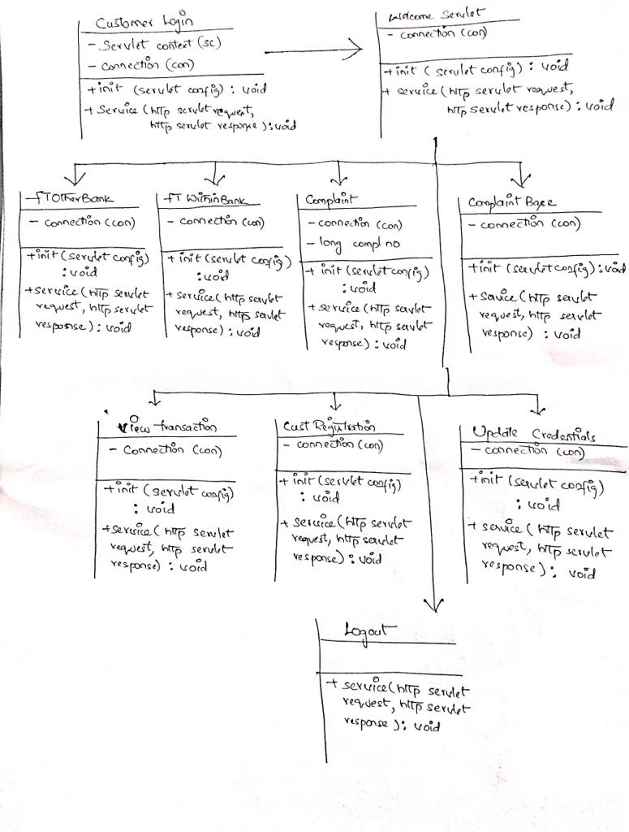

**Activity Diagram:**

Fund Transfer

Correct/ Incorrect

User Id and Password

Login

Wrong Credentials Right Credentials

Operations

Lodge Complaints

View Complaint Box

View Transactions

Change Credentials

The above diagram explains the process flow in the system. And please note the operations are not required to be in the same order as all those are independent. It is used to show all the activities which occur in the project.

**Sequence Diagram:**

The Sequence diagram shows the interaction between admin, customers and customers account in the order.

Admin Customer Account

Add Customer

Fund Transfer

Lodge Complaints

View Complaints

View Transactions

Update Credentials

Logout

**Deployment Diagram:**

The deployment diagram shows the internal activities which are performed when the user starts the activity from the web interface.

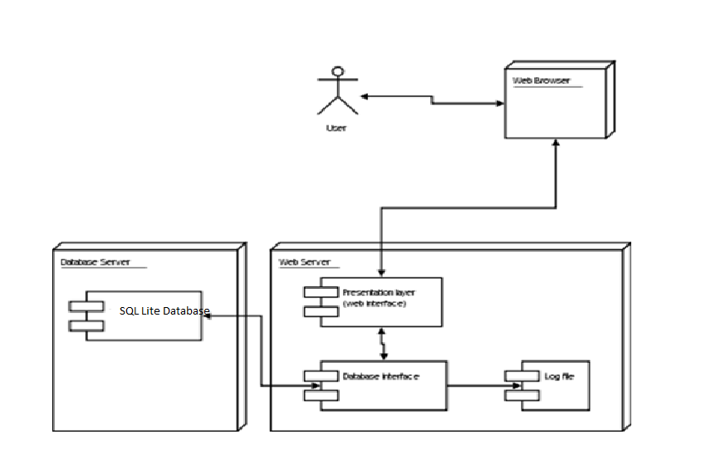

Initially the user uses the web interface to login in to account using credentials, once logged in then it takes to home page of account then he/she can view account balance and transaction details. Once user is done with all the activities then user can log out.

**Interface Design:**

**User and System Interface:**

In the User and system interface it is easy to read by all type of users and easy to accessible. In this interface we have various pages opening up as part of user interaction with the application. Home page contains links to 6 other pages and they are:

1. Home
2. About
3. Products
4. Contact
5. Careers
6. Customer Login

**Home Page:**

The home page is first interface page of our project, it is searched in the web browser with its domain name. In the home page it contains bank description and some advertisements about the bank and offers for the bank account holders and it is a dynamic page so it has multiple images which is scroll from right to left automatically with certain time gap.

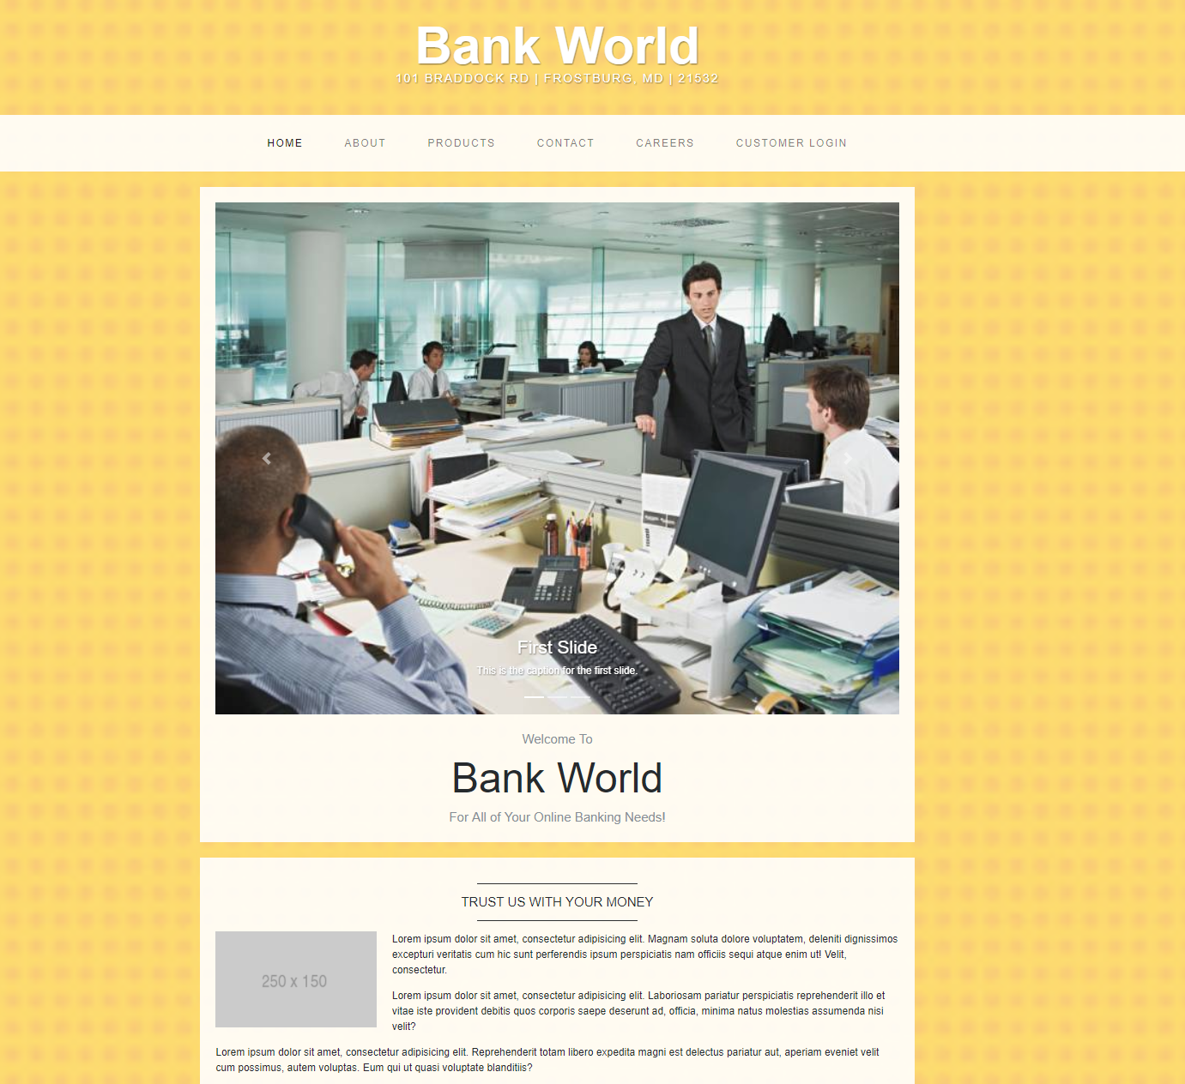

**About:**

In this about page it describes about the bank like when it is established and CEO details, founder details. Along with it describes about how many branch locations it has team peoples list in the about page like their name and their positions in the bank.

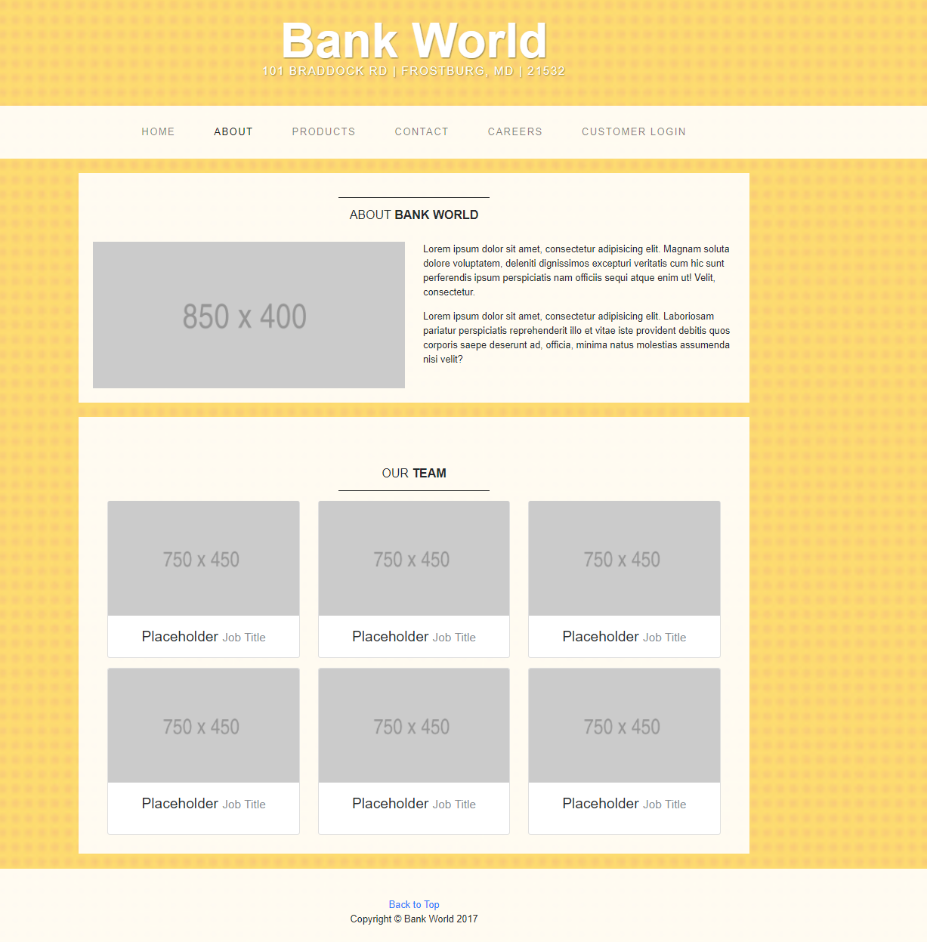

**Products:**

In the product page it describe about the available products for the customers. The products like credit cards, fund transfer, deposit etc. like various opportunities to the registered users and new upcoming bank customers.

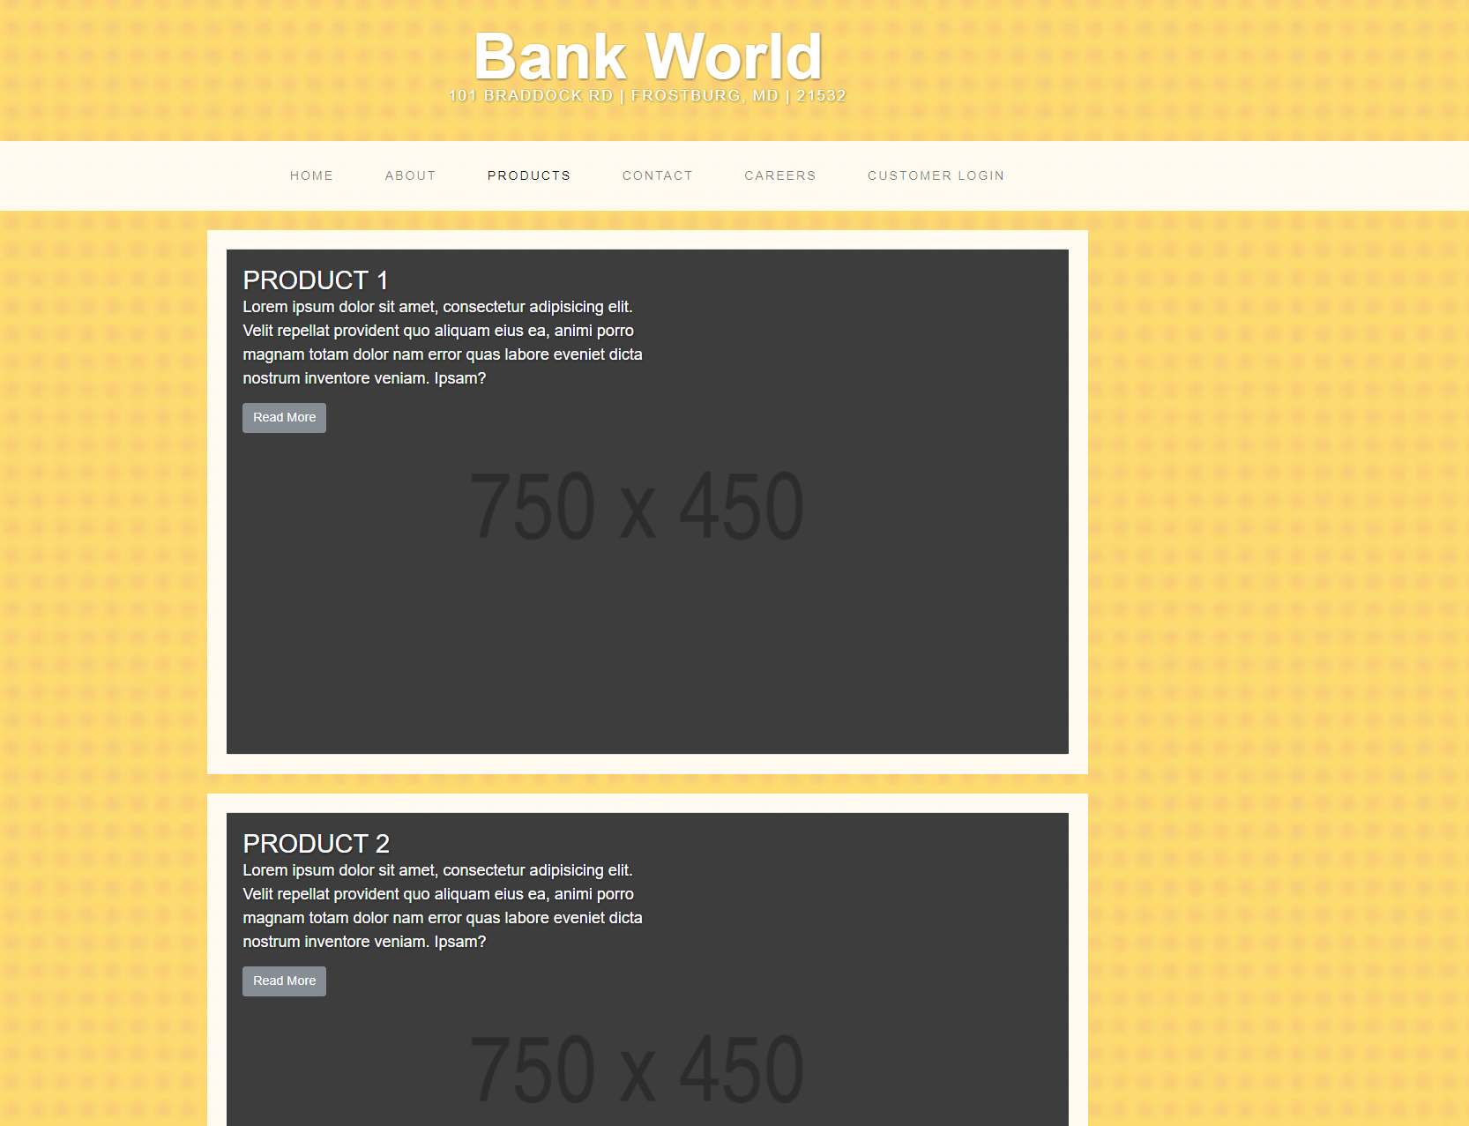

**Contact:**

In the contact page it is like contact us. For the customers/ users if they have any quires and doubts about new account opening, existing users offers and fund transactions, balance statements and account activity. In this page it displays the customer service number, email and toll-free contact details to contact with automated machine without any interaction with customer representatives for some predefined questions. Without calling customers can submit their questions using the default contact form.

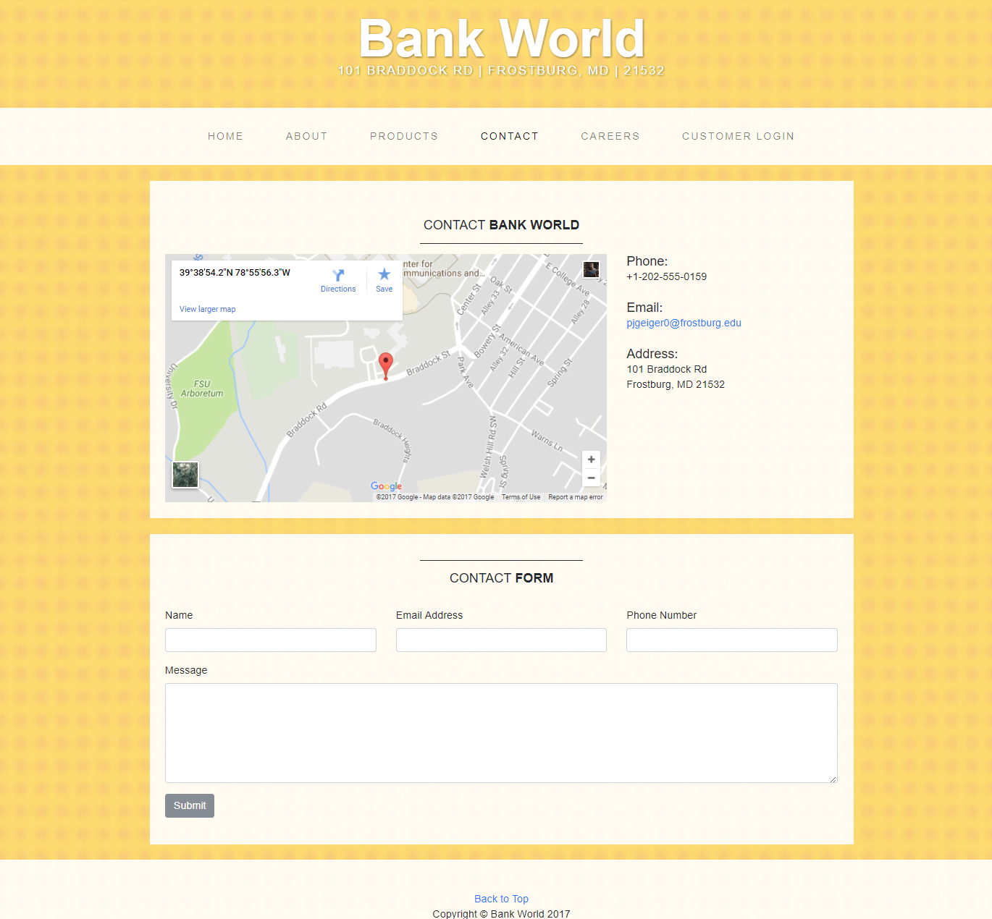

**Careers:**

In the careers it displays the job opportunities for the job seekers with the updated jobs and old jobs. Every new coming like interview, closed jobs, call letter and all are displayed in this page.

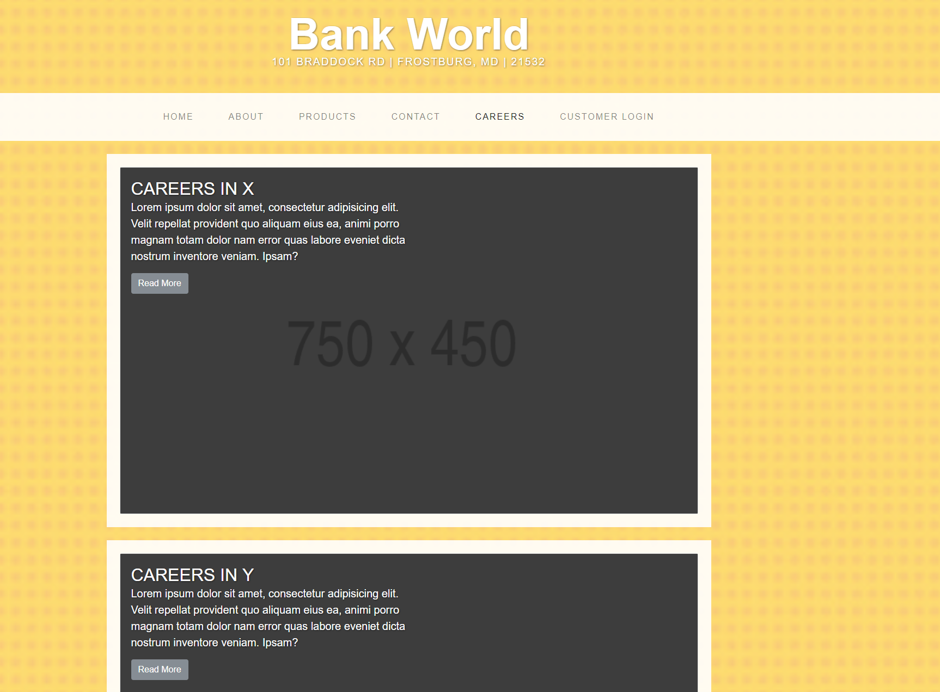

**Customer Login:**

In page it is default for the registered customer to login with their credentials like user name and password and it display on the page like welcome back. For the new customer there is link at the bottom of the page like register here. Once they click on that link it will take them to the register page and first time online banking users can register with their personal and account details. After registered they can login with their credentials in the page.

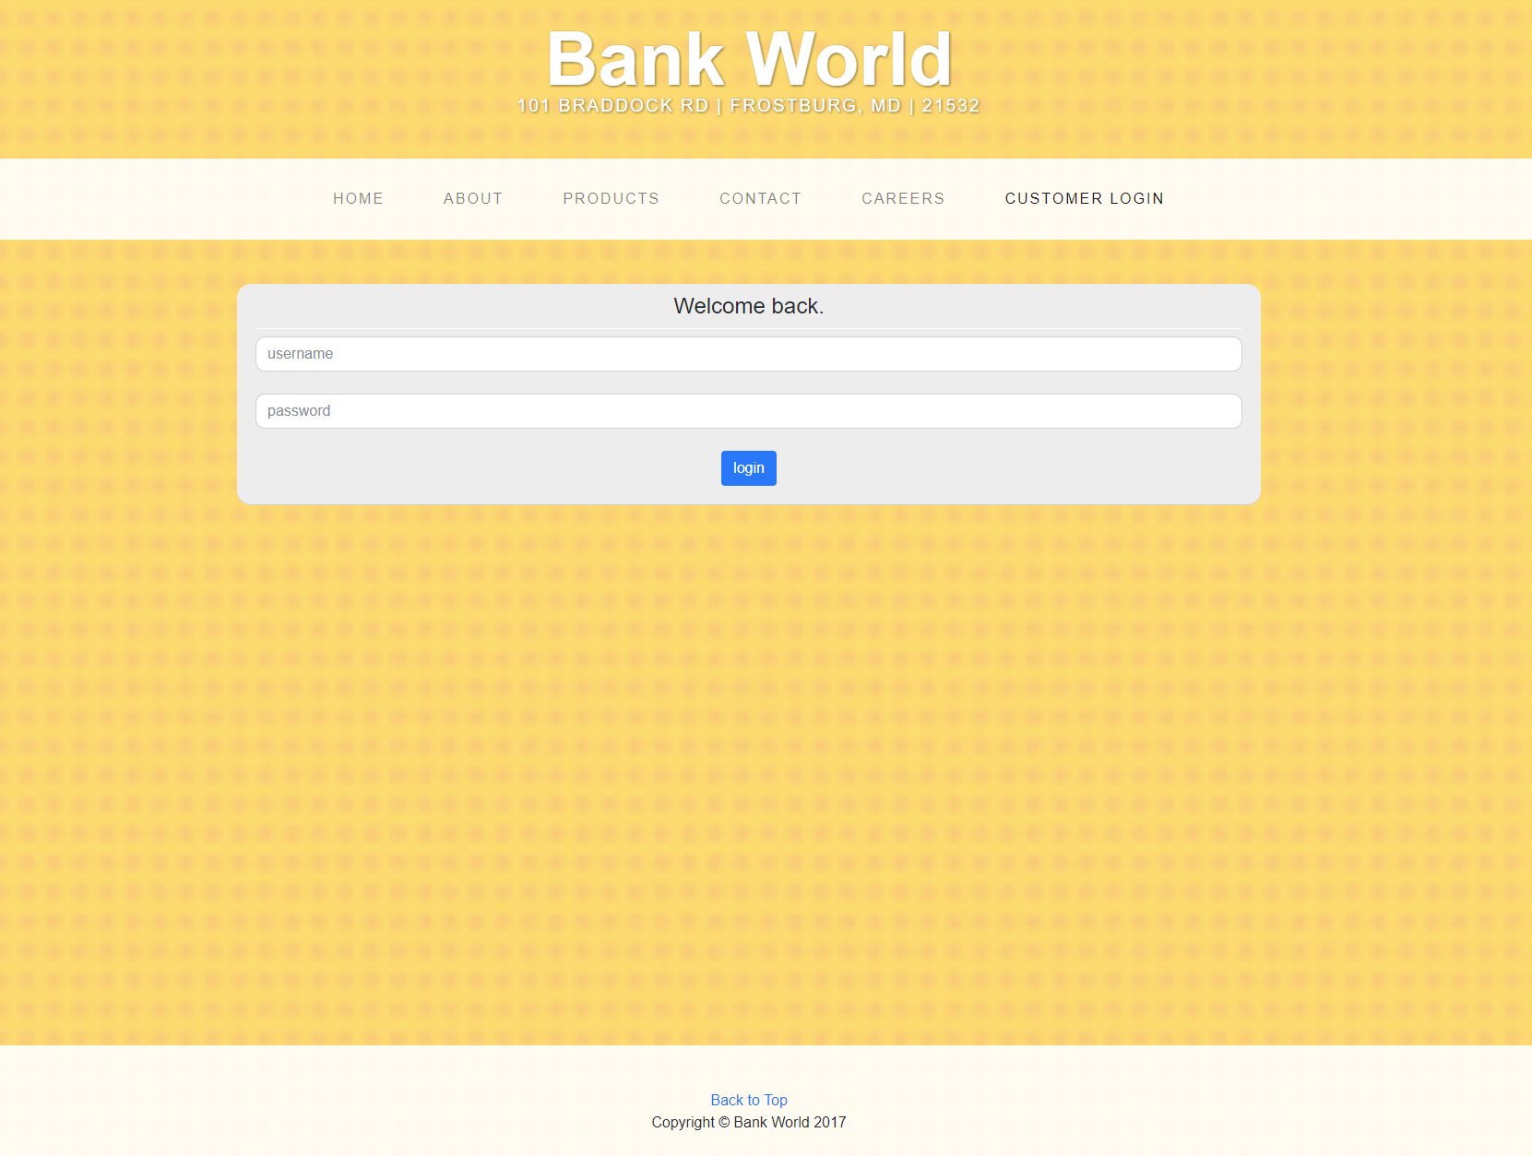

After Customer get logged in he can see all the options in his/ her dashboard. Below are the screens which show the user dashboard. The below screen include the user registration page.

**Registration Page:**

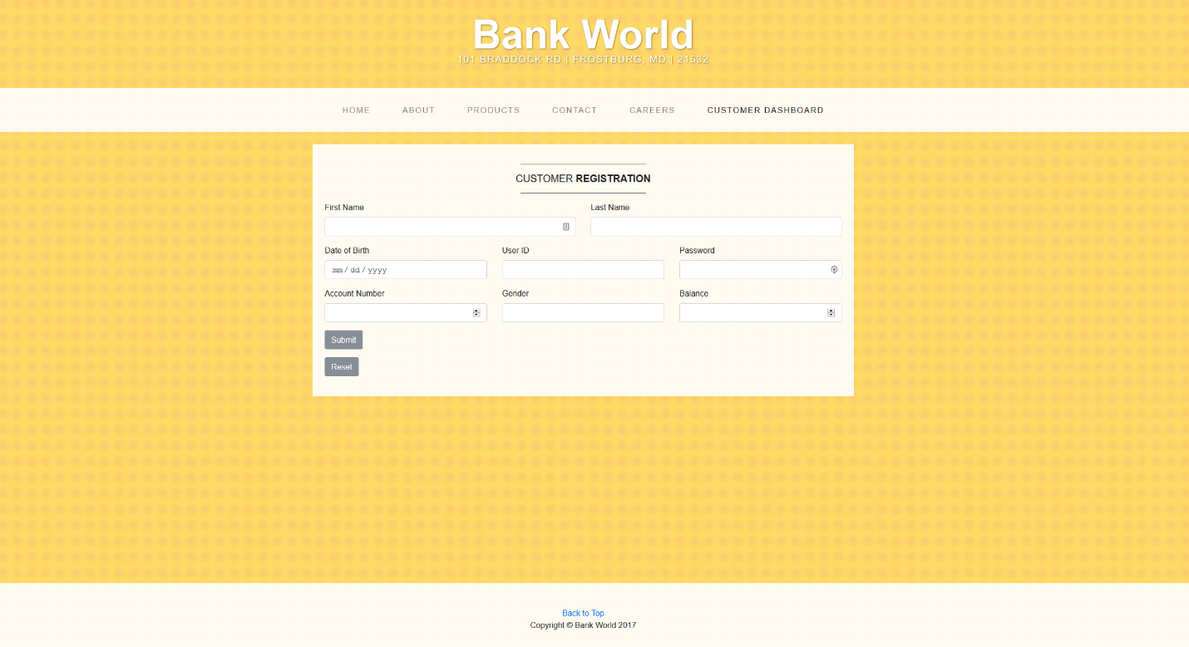

**Fund Transfer Inside Bank:**

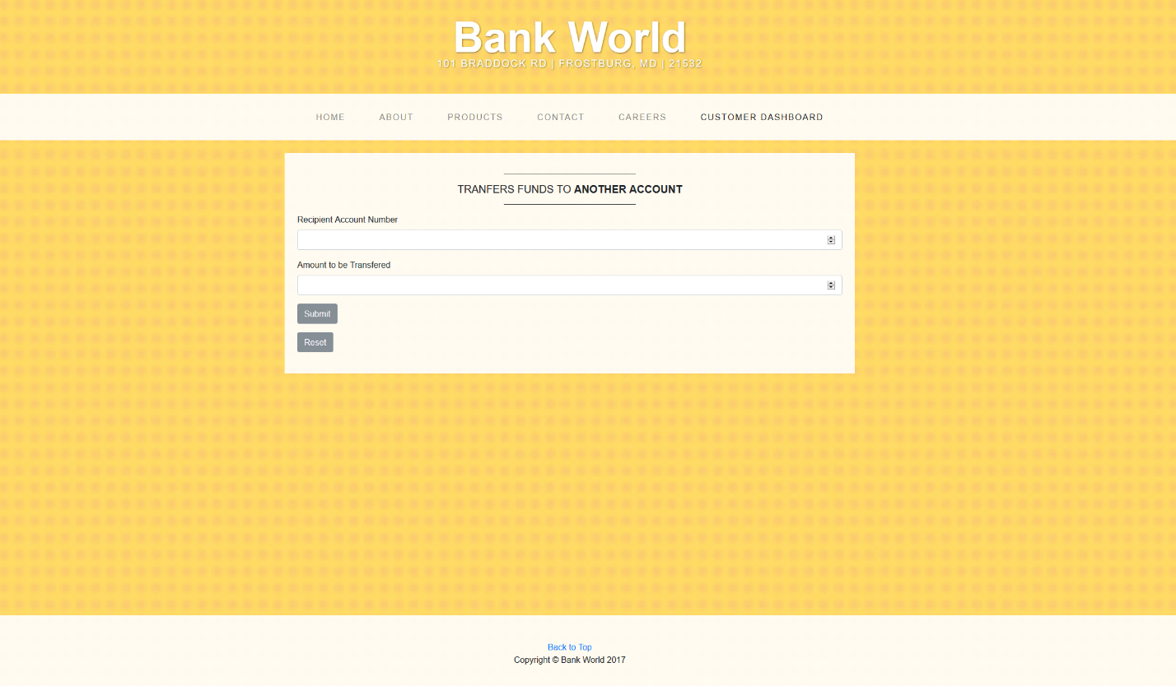

**Fund Transfer Outside Bank:**

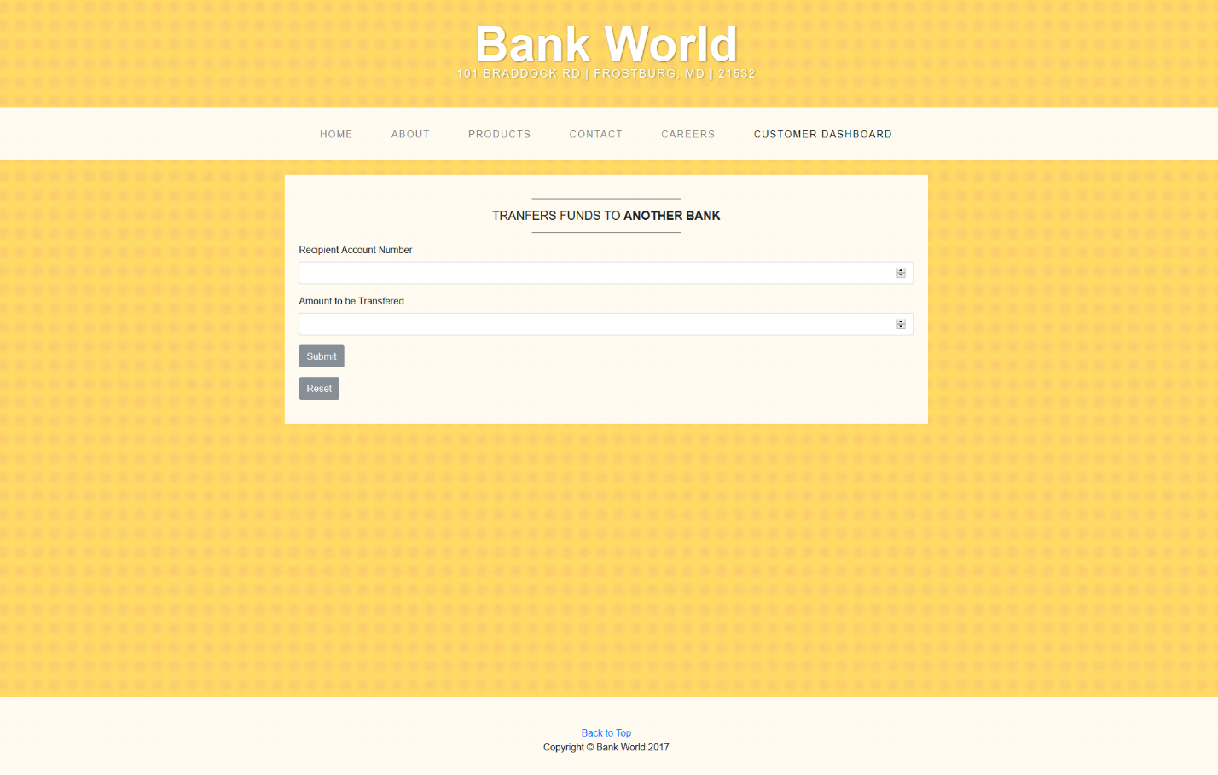

**Complaint Page:**

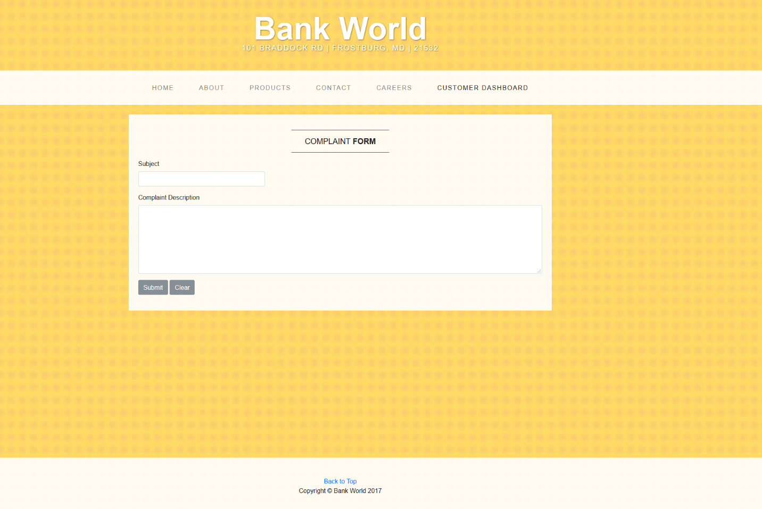

**Change Credentials:**

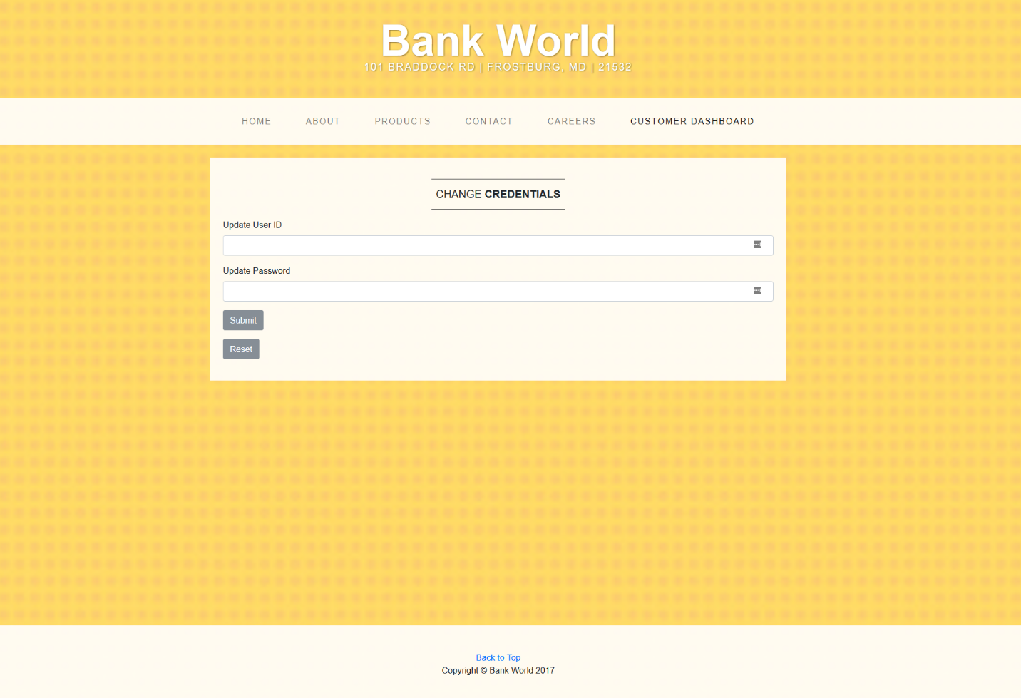

**External Interface Design:**

In this external Interface the website must be available for both system (Laptop, Desktop) and mobile devices. The Website must be accessible by any browser and it should support all the browser formats. The Browser like Internet Explorer, Google Chrome and Mozilla Firefox which depends upon user’s preferences.

**Hardware Interface Design:**

Keyboard: This is used to type the words to create a file and write code, run code and give inputs to get outputs.

Mouse: Mouse/ mousepad is used to click the preferred content.

Monitor: It is basic, used to display all the contents in the system.

**Procedural Design:**

**Customer Register:**

1. Initially a customer needs to get a bank account. After he/she gets an account they need to register for the online bank account.
2. For registering the bank account for online operations, Bank admin user has to register them with all the details of username, password, first name, last name, Dob etc.
3. When customer providing his details to register while giving the password it should be strong, and it must satisfy the requirements like at least one uppercase and lower case letters, in the password use some special character and use numeric values.
4. All of these may be mixed up or individual it is depending on user.
5. Once the user is registered then his/ her credentials are stored in the bank database.

**Customer Login:**

1. Once the user get access then he/ she needs to login to their account using their credentials.
2. If the user gives the wrong credentials, then it will not able to retrieve the user information and user is prompted for correct credentials.
3. So, the interface says that wrong credentials and try again with valid user name and password.
4. Then user needs to give the right credentials properly. Once the user provides correct credentials, then it will take the user to his bank account homepage.
5. After user is logged in then he/ she can view all the options he is having in his account. The options are:
6. View Transactions.
7. Fund Transfer with in bank
8. Fund Transfer to other bank
9. Lodge Complaints.
10. Check Complaints Status.
11. Change Credentials.
12. Logout.

**View Transactions:**

1. The user can able to view his/ her current available balance in his/ her checking and savings account.
2. User can possibly view his/ her previous credit and debit transactions.
3. If user want to know that when and who he/ she had made his/ her recent transaction, then he/ she can view in this page.

**Fund Transfer:**

1. If user has enough balance in account, then he can transfer funds.
2. User has option to transfer funds with in bank and transfer funds to other bank
3. If funds transfer is with in bank, then application checks for correctness of the account.
4. If funds transfer is to other bank, then application does not check for correctness as the other bank’s database will not be available with us
5. After successful transfer, user’s updated balance information is shown to customer and it is updated in database and transaction data/table is also updated.

**Lodge Complaints:**

1. If the user has any problem with his account or transactions, then user can register a complaint with bank using this page.
2. User can make a complaint using the subject and he can describe his problem in the description.
3. Once user submits, complaint will be registered in bank database and can be viewed by bank’s officials.
4. For every complaint, a unique complaint number will be generated by database.

**Check Complaint Status:**

1. When user dropped the complaint, user can check their complaint’s status or can view details of complaint submitted.

**Change Credentials:**

1. If the user needs to change login credentials (user name and password) then they can change either of them.
2. If user wants to change only password, it can be done
3. If user wants to change only username, it can be done.

**Logout:**

1. When user wants to logout, he can click on Logout option which ends the session.